Types of Programming Language
- Procedural:
- Specifies a series of well-structured steps and procedures to compose a program
- Contains a systematic order of statements, functions and commands to complete a task.

- Functional:
- Writing a program only in pure functions i.e. never modify variables, but only create new ones as an output.
- Used in situations where we have to perform lots of different operations on the set of data, like ML.
- First class functions?

- Object Oriented:
- Revolves arounds objects
- Code+Data = objects
- Developed to make it easier to develop, debug, reuse and maintain software.

Static Vs Dynamic Language
Static | Dynamic
Performs type checking at compile time | Perform type checking at runtime
Errors will show at compile time | Errors might not show till program is run
Declare datatype before you use it | No need to declare datatype of variables
More controls | Saves time in writing code but might give errors at runtime
Fixed before program run  Same for everyone  Class-level | Decided when program runs  Can change per object  Object-level

Memory management
Types of Memory in Computer
Stack | Heap
A – ref variable | 10 - object
Variable names are stored in stack | Actual data is stored in heap
a is going to point to 10 in heap memory
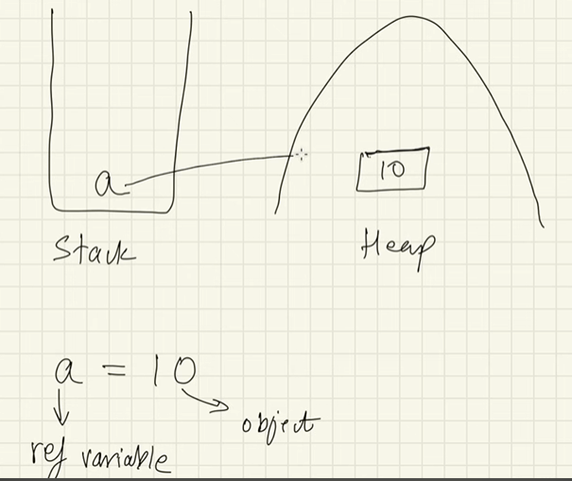

Pass by Reference Concept:
a= [1,2,3,4,5]
b =a;
a[0] = 66;
b[0] = 66;
- If object was changes via one reference variable, then the object will also change will also be visible to all other reference variables pointing to the same object

No Reference Variable to the object:
Ex. – No name to the person (no reference variable)
- No variable pointing to the memory
- This object will be removed from the memory when garbage collector hits
- Java auto hits garbage collection

How Java Code Executes

- Difficult to write code in machine format
- Java code is stored in .java file
- Compiler, compiles entire file and create .class file (byte code).
- Byte code cannot directly run on the system, we need JVM to run this code
- Interpreter will compile the code line by line using JVM
- Machine code is generated (0 and 1)

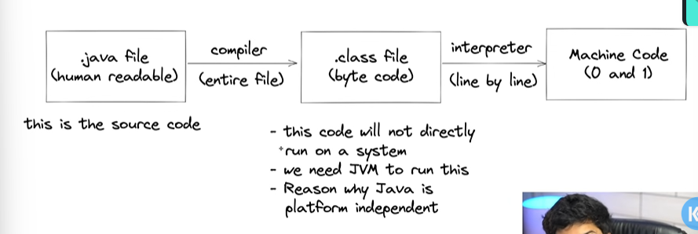
- Platform independent

- Byte code can run on any other system
- We need to convert src code to machine code so computer can understand
- Compiler helps in doing this by turning it into executable code
- This executable code is set of instructions for compiler
- After compiling C/C++ code we get .exe file which is platform dependent
- In java we get bytecode, JVM converts this to machine code
- Java is platform-independent but JVM is platform dependent

- JDK vs JRE vs JVM vs JIT

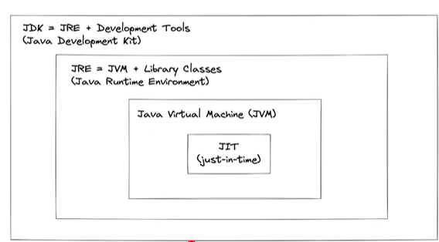

- JDK
- Provides environment to develop and run Java Program
- It is package that include:

1. development tools – to provide an environment to develop your program
2. JRE – to execute program
3. a compiler – javac
4. archiver – jar
5. docs generator - Javadoc
6. interpreter / loader

- JRE
- It is an installation package that provides environment to only run the program
- It consists of:
1. Deployment technologies
2. UI toolkits
3. Integration libraries
4. Base libraries
5. JVM

- After we get the .class file, the next things happen at runtime:
1. class loader loads all classes needed to execute the program.
2. JVM sends code to Byte code verifier to check the format of code

- (How JVM works) Class Loader
- Loading:
- reads .class file and generate binary data
- an object of this class is created in heap
- Linking:
- JVM verifies the .class file
- allocates memory for class variables & default values
- replace symbolic references from the type with direct reference

- Initialization
- all static variables are assigned with their values defines in the code and static block

- JVM contains the Stack and Heap memory allocations.

- JVM Execution
- Interpreter:
= Line by line execution
= when one method is called many times, it will interpret again and again
= functions that are used multiple time, that many times interpreter will go again and again
= hence to solve this problem JIT works.

- JIT
= those methods that are repeated, JIT provides direct machine code so re- interpretation is not required.
= makes execution faster

- Garbage Collection

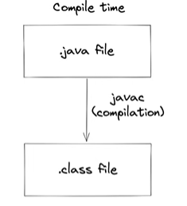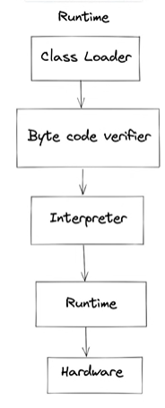

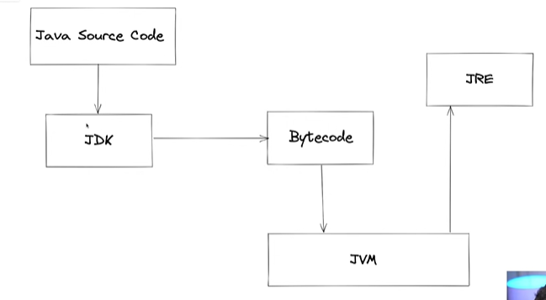

First Java Program

